uNIHASH Product Disclosure Statement
14 August 2019
Issued by
Unihash Team
Address
Level 7
257 Collins Street
Melbourne, Australia 3000
Website
unihash.io

- Important Notices
It is important that you read this document carefully and in its entirety prior to participating in the Unihash ecosystem. You should seek personal advice from your accountant and legal representative prior to acting on the information contained in this Public Disclosure Statement (PDS).

Issuer of PDS
The issuer of this PDS is the Unihash Team.
Not Securities
The product described is not an offer of securities.
This material is provided by the Unihash Team for informational purposes only and is not an offer or a solicitation to buy or sell securities or engage in financial services.
No Investment Advice
The product offered is not offered for investment purposes. The information contained in this PDS should not be taken as financial product advice and has been prepared as general information only.
To the extent permitted by the applicable International Laws, regulations and rules and those of the participants country of residence, The Unihash Team shall not be liable for any losses that are indirect or otherwise, that may be in connection to the reliance of this Document.
Please consult your legal, financial or business professional for advice prior to participating in the Unihash ecosystem.
Prior to the participation in the Unihash ecosystem you should carefully address the general risks involved with blockchain technology.
Invitation
The invitation contained in this PDS is for the participation in the Unihash ecosystem via UniHash Coins which has been construed to fall under the category of a digital currency.
No individual or body is authorised by the company to give any information or make any representation in connection with this offer that is not contained in this PDS.
All information that has been held out but is not contained in this PDS may not be relied upon as having been authorised by the Unihash team.
Neither a representative of a company or any persons associated with the company may warrant the future performance of the Unihash Ecosystem or Unihash Coins.
Past Performance
Past performance of the Unihash Team should not be relied upon as indicative of future performance.
Expiry Date
This PDS expires 6 months following this document’s publish date.

Representation and warranties

By accessing this document or any part thereof, you acknowledge, understand and agree that:
- Unihash does not afford the participant to any rights or obligations in the Unihash ecosystem;
- This document does not constitute a guarantee or a promise of; future prospects, features of the ecosystem and/or any form of legally binding agreement between the Unihash Team and the reader of this document;
- You are permitted to access this document pursuant to the laws of your country of residence;
- The redistribution or dissemination of this document, or any part or section thereof, is prohibited without the permission of the Unihash Team;
- The Unihash Team and/or its affiliates are not liable for any losses of any kind arising from the reliance of this document; and

- Information in this document does not constitute legal, financial, business or tax advice.

Jurisdiction

The PDS has been prepared to comply with international law.
The Unihash ecosystem will be regulated under international law and any other applicable law. Participants of the Unihash ecosystem will be regulated by International laws, laws of their country of residence and any other applicable law. This PDS does not constitute an invitation in any place in which, or to any person whom, it would not be lawful to make such an invitation.
The distribution of this PDS (whether electronically or otherwise) in certain jurisdictions may be restricted by law. Persons who come into possession of this PDS should seek their own advice and observe any such restrictions.
Any failure to comply with such restrictions may constitute a violation of applicable laws. Unless otherwise agreed by the Unihash Team, any person participating in the Unihash ecosystem shall be by virtue, deemed to represent that they are in a jurisdiction that permits the participation detailed in this PDS, and is not acting for the account or benefit of a person within such jurisdiction that does not permit participation detailed in this PDS.

Guarantee
This document does not afford any guarantees or promises. All features referenced to in this document or related documents are not guaranteed. This document does not guarantee that the services mentioned will be released. If a product is released there is no guarantee that the product will resemble or abide by the features listed in this document. This document should not be relied upon as a promise or representation of the future projections of the Unihash Team.

Currency

Unless expressly stated, monetary amounts are expressed in US dollars.

Photographs and Diagrams

Diagrams and maps used in this PDS are for illustrative purposes only. All information represented in the charts, graphs and tables are based on information available as of the listed date.
Distribution of Document
The distribution or dissemination of this document or any part or section thereof, is prohibited without the consent of the Unihash Team.
This PDS may not be distributed to or relied upon by any person in China or the United States.

Privacy

By participating in the Unihash Ecosystem, you are required to provide personal information to the Unihash Team. A full list of personal information used will be listed on Unihash.io’s privacy policy.
Participants domiciled or a national of a European country may make request for personal information to be deleted at any time as per the GDPR. However, users who request the deletion of their personal information will be forced to cease use of our services.

Blockchain General Risks

Blockchain technology presents many inherent risks. Please ensure you are either well informed in relation to blockchain technology or have consulted a blockchain advisor prior to participating in the UNIHASH ecosystem.

Updated Information
Information relating to the offer may need to be updated from time to time. Any updated Information about the offer not materially adverse to the product offering will be made available at Unihash.io.

Unihash may issue a supplementary PDS to supplement any information not disclosed in this PDS.

- Table of Contents
Table of Contents
1. Important Notices 2
2. Table of Contents 6
3. community’s Greeting 8
4. Overview 9
5. Introduction 11
6. Neuron Wallet 12
7. Smart Contracts 16
8. Purchasing Goods and Services with Unihash 16
9. UniHash Coin 17
10. Exchange 19
11. Unihash Blockchain 20
12. Staking 21
13. Scalability 26
14. Sustainability 26
15. Marketing 27
Positioning 27
Competitors 27
Opportunities 28
Threats 28
Target Market 28
16. Competitor Analysis 29
17. Roadmap 30
18. Intellectual property 32
19. Validity of Product Disclosure Statement 32
20. Blockchain 32
21. Partnerships 32
22. Team 33
23. Definitions 34

- Community’s Greeting
Dear Unihash Ecosystem Participant,
It gives us great pleasure to invite you to become a member of our Unihash ecosystem.
As you will find out our blockchain incorporates many concepts of other blockchains in which we have built upon to differentiate ourselves. Our blockchain is semi-private as all Unihash coins have been pre-mined and the Proof of work consensus algorithm used to maintain the network is solely preserved by us.
We currently operate in Australia, Malaysia and China as the hubs of our ecosystem. To do this we must ensure precautions to prevent Unihash ecosystem members from finding themselves within an adverse environment. Thus, to achieve this we have created a hub in Australia and wish to use the Australian regulatory framework as a guideline. The Australian regulatory framework has not, yet, created specific laws in relation to digital currency. However, their laws provide exceptional protection to the retail individual.
As a member of the Unihash ecosystem, we seek to ensure the proper maintenance of our blockchain and ecosystem participants.
For those of you seeking a fully decentralised blockchain ecosystem this project may not be for you, but for those who do not mind, we will endeavour to provide the Unihash ecosystem participants every advantage possible that is within our power.
Yours Faithfully,

Unihash community

- Overview
Topic | Summary
What is Unihash? | Unihash is a company that has created a digital currency payment ecosystem.  Our Ecosystem consists of:  - A Blockchain Platform;  - A Custom Digital Currency Wallet;  - A large pool of Merchants;  - A Digital Currency Exchange;  - Unigram;  - Uni-E; and  - The Unihash Coin.  We are currently in talks to implement the following into the Unihash ecosystem:  - A Security Token Platform;  - A Security Token Exchange;  The Unihash ecosystem currently allows:  - Users to purchase goods and services with their digital currency via QR code.  - Merchants to accept digital currency as a payment mechanism.  - Merchants to liquidate their digital currency conveniently.  Unihash is currently in discussions with relevant to parties to allow, via the Unihash ecosystem:  - The purchase of unlisted traditional securities and security tokens;  - The purchase of listed securities on a legally compliant stock exchange;  - Initial Exchange Offerings of Crypto Currencies.
Where does Unihash Operate? | Unihash operates internationally.
Who Owns the Unihash Ecosystem? | The Unihash ecosystem is owned by various companies.
How Does Unihash Generate Revenue? | - Digital Currency Exchange – Revenue will be generated via the operation of Unihash’s digital currency exchange Barters Trade.  The digital Currency exchange will charge a transaction fee for every transaction made on the exchange, thus as volume increases so will transactions and revenue.  The Digital Currency Exchange will also generate revenue via listing other crypto currencies on the exchange for a fee.
How Can I Participate? | An individual may attain Unihash Coins by purchasing it from another individual.  Once our exchange Barters Trade is operational individuals may sell and purchase Unihash on the platform.

- Introduction
Unihash is a multinational corporation with businesses and partnerships spanning across South East Asia. Our Unihash ecosystem has over 32,000 merchant partners in Malaysia, China, Australia and Indonesia.
Unihash wishes to create an international payment ecosystem. We hope to achieve this via the Unihash ecosystem.
The Unihash coin will be used as the prominent medium of exchange for our international merchant network.
Unihash Coin is a digital currency used for payment transactions. Its code has undergone rigorous development that has allowed the implementation of key features that differentiates Unihash from other crypto currencies. The most prominent being the implementation of smart contracts.
Our vision is to allow our international merchant network to accept Unihash Coins and liquidate these coins instantly for Fiat Currency allowing merchants to cover their management and operating costs. However, our long-term goal is to ensure that operating costs may be managed with the Unihash coin rather than being paid with Fiat.

- Neuron Wallet
The Neuron wallet is a safe and secure IOS and Android wallet specifically built for the decentralised storage of Uni-E, Unihash Coins and Unigram. As well as the aforementioned crypto currency, it will also store user’s Bitcoin if they choose to do so.
Neuron wallet is a cold wallet. Private keys are securely stored in the user phone’s local database. Thus, transactions from one wallet to another is recorded on the Uni-E block explorer which can be found here “explorer.Uni-E.io”
To promote adoptability and retail use we have created a clean simple to use wallet application for our users. Neuron Wallet screen 1 shows the home screen of the Neuron Wallet. We have built the wallet with a simple User Experience and design. Some of Neuron Wallet’s features include:
- The total value of your digital currency held in your wallet displayed in USD.
- The number of Unihash Coins the user has in their wallet (may also show Bitcoin if stored in this wallet).
- The creation of multiple wallets from a single login.
- A simple receive button, when clicked will open ‘Neuron Wallet screen 4’ to seamlessly receive Uni-E from others.
- When clicking the 3-line button next to the receive button, the user will be prompted to select the wallet they would like to receive your Digital Currency in.
- A basic diagram of the market fluctuation in relation to the digital currency held in your wallet.
- A simple send button. When prompted, it will open Neuron Wallet screen 3. This allows users to simply send their Unihash, Uni-E and Unigram Coins to others by simply inserting their address or scanning their QR code.
‘Neuron wallet screen 3’ details the features of the Neuron Wallet. Remaining true to our concept of simplicity we have only included basic options for the wallet such as viewing previous transactions, sending and receiving Uni-E Coins, changing the settings and viewing the block explorer. The most complicated feature listed, which is still in development, is our smart contract applications tab otherwise known as Mini Programs.
Smart Contract implementation will be available to users of the Neuron wallet via the mini program tab. It will allow users without any coding or development knowledge to make use of pre-existing smart contracts that have been developed by Unihash or others.
The mini program tab allows users to use pre-developed smart contracts and implement them directly into our application, this is evident in ‘Neuron Wallet Screen 5’. As displayed on screen 5 we have implemented a very simple smart contract that will allow our users to send money via a Red Packet. As many of our users are influenced by Chinese culture, we have implemented a red packet smart contract that will basically gift UNIH, UniG or Uni-E to users in the form of a red packet.

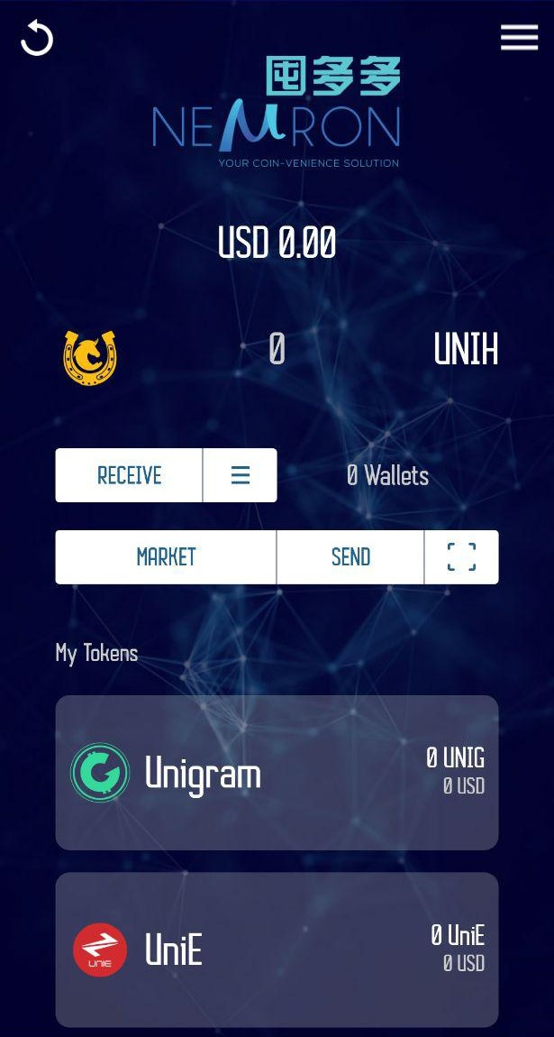
Neuron Wallet Screen 1

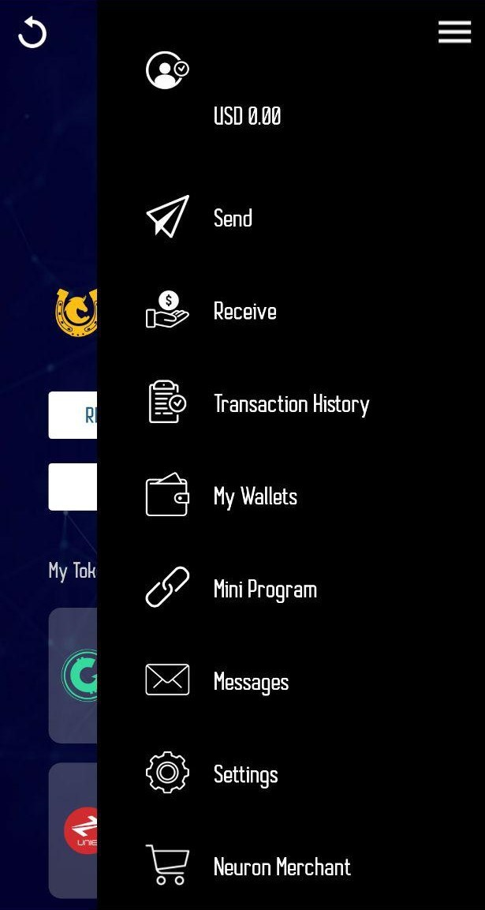
Neuron Wallet Screen 2

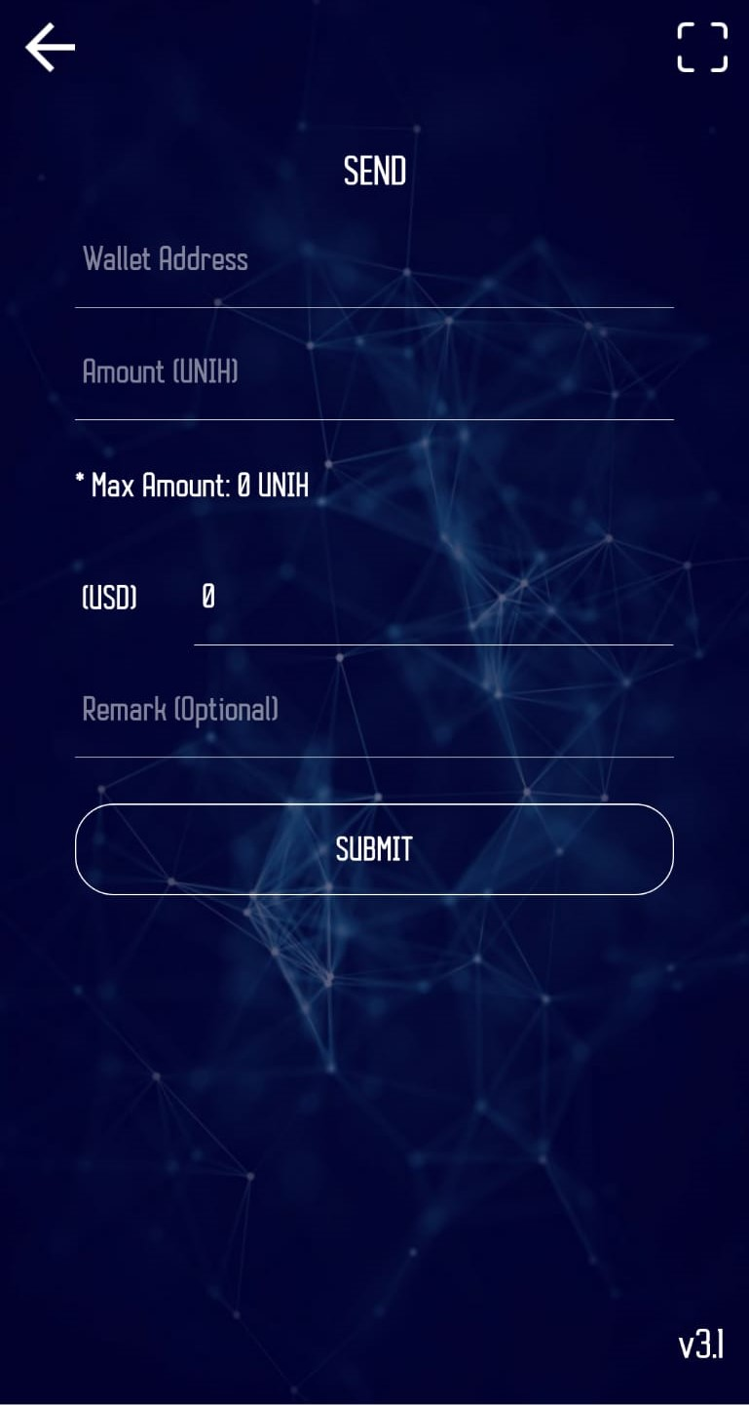
Neuron Wallet Screen 3

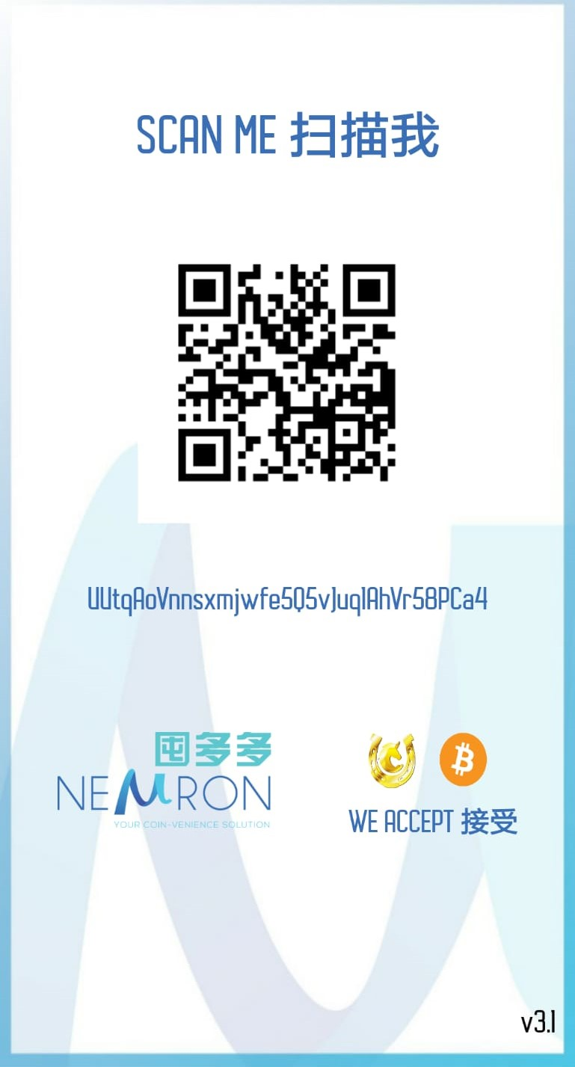
Neuron Wallet Screen 4

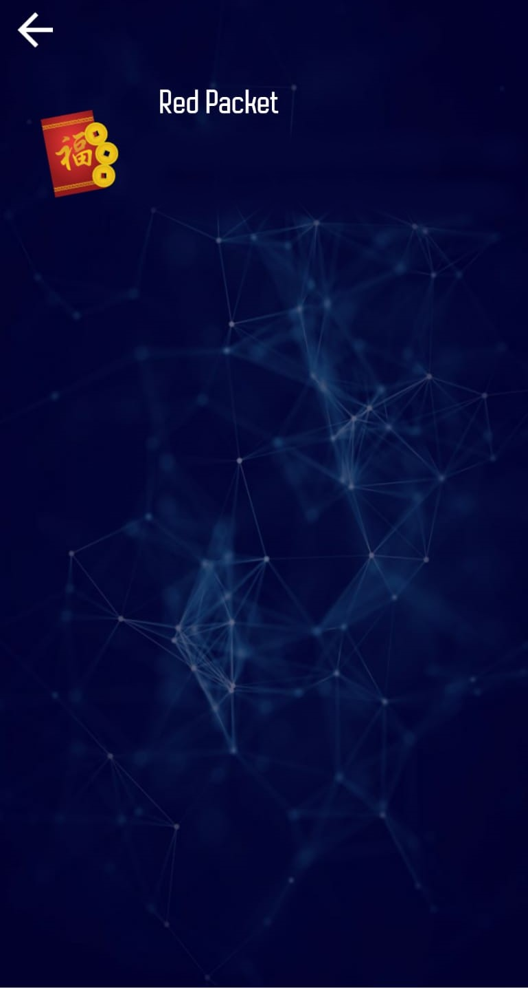
Neuron Wallet Screen 5

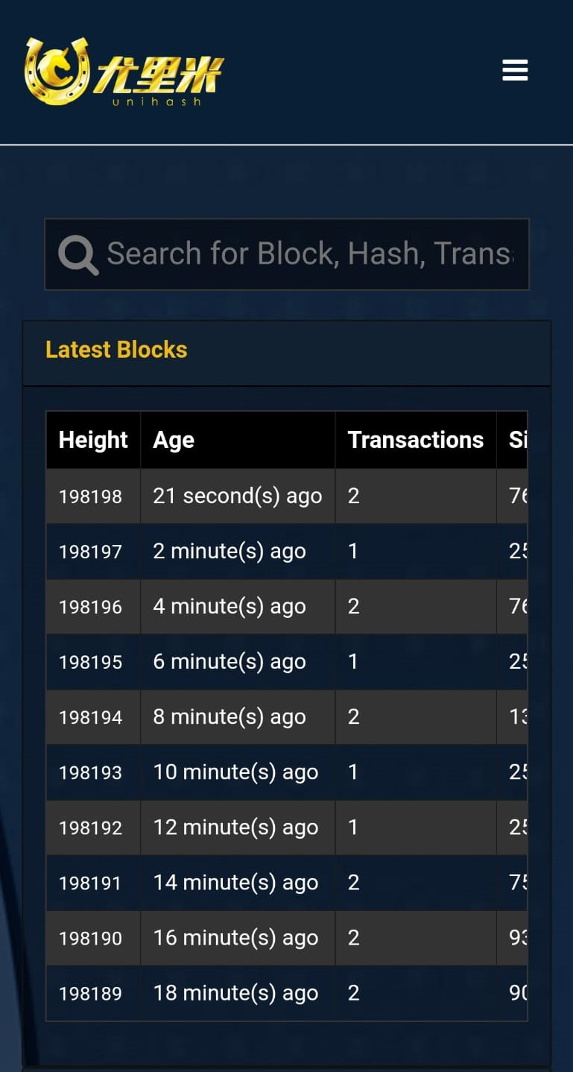
Neuron Wallet Screen 6

- Smart Contracts
We are currently developing smart contracts on our platform that will initially be accessible on the Neuron wallet.
We aim to develop smart contracts that will allow people without an IT background to use and potentially build smart contracts on the Unihash blockchain.
Our vision is to allow our ecosystem participants to build on top of our blockchain. For example, allowing users to easily and simply create their own token on the Unihash blockchain.
- Purchasing Goods and Services with Unihash
To purchase goods and services at one of our affiliated merchants the user must have the Neuron Wallet installed on their mobile phone, as well as the necessary balance of Unihash to purchase the item.
When our affiliate merchants ask for your payment method and Unihash is chosen, they will display a QR code on their screen along with the amount of Unihash owing and the price displayed in accordance to the fiat accepted by the merchant’s domiciled country of residence.
Once the merchant’s QR code is displayed, the user simply clicks the send button on the Neuron Wallet and scans the merchant’s QR code. The Neuron wallet will display the amount that is being sent from your wallet to ensure that the price displayed on the merchant’s screen corresponds to the price that is being requested.
The Neuron Wallet will prompt the user to accept the transaction. If the user accepts, the payment will go through instantly.
If you wish to be an affiliate merchant, please view our guide here http://www.shoppingpin.com/neuron_guide.php.

- UniHash Coin

Unihash Coin
(UNIH)

What is a UNIH? | UNIH is a digital currency created by Unihash that is intended to be used as a medium of exchange in the Unihash Ecosystem. UNIH is built on C++ and has been developed to create a unique product.  Please note – Unihash is the initial distributors of UNIH. Unihash does not own UNIH, nor can the UNIH be taken away from an individual without their consent. UNIH is owned by the individuals who are holding the coins in their wallet and will remain so indefinitely.
What is UNIH uses? | The benefits for UNIH include:  - Purchasing goods and services internationally B2C transactions.  - Sending money to your friends and family instantly C2C transactions.  - Staking to receive Uni-E.  As other use cases that arise for UNIH it will be updated in a supplementary document.
Rights and Obligations | Owners of Unihash Coins have complete ownership of the coins. This means it can be used for whatever purpose they see fit. Any rights conferred are conferred by an individual or merchant that accepts Unihash as a payment method.  There are no obligations attached to the Unihash Coin.
UNIH Transaction/  Movement  Fees | This will be provided in a supplementary document.
UNIH Total Token Supply | 210,000,000
Circulating Supply | 210,000,000
Digital Currency Offering | Currently there are two ways in which a user can receive Unihash.  1. Purchase UNIH from another individual who owns UNIH.  2. When our exchange platform is operational users will also be able to purchase UNIH from the platform.
Consensus Algorithm | Proof of Work
Block Time | 2 minutes
Cooling Off Period | There is no cooling off period available if purchased via an exchange, mined or received from another individual in the Unihash Ecosystem. Once purchased, received or sent Unihash Coins cannot be refunded nor recovered without undergoing a new transaction.
Tax Implications | Please consult your accounting professional in your country of residence.
Restrictions of Token | UNIH will be restricted to the Unihash Chain. All transactions fees will be paid in Unihash coins.
Risk Associated | Regulatory Risk  The legal framework regarding Blockchain Technology has not yet solidified. We cannot promise that the current Unihash structure will comply with future regulations, however we will do everything within reason to ensure that we remain fully complaint with Australian and applicable international laws.  Security Risk  Digital Technology is and always will be susceptible to extrinsic attacks that will attempt to penetrate and/or steal digital assets within the Unihash ecosystem. Please be aware of this before you make your purchase.  Transfer Risk  If the user sends Unihash to an incorrect address the user will never be able to recover the Unihash.  When sending Unihash to another address the user must take the necessary procedural action to ensure that the sending address is correct.  Procedures that may be followed include triple checking the address digits, directly scanning the associated QR code and checking the address or asking the recipient to input their own address to pass the liability onto them.  Volatility Risk  The price of Unihash Coins may be subject to volatility and market forces as the currency is not controlled by a centralised entity. This means a user may purchase Unihash Coin at a particular price and the price may increase or decrease from the time of purchase or exchange.  Theft Risk  If the user’s Unihash Coins are stolen from their wallet there is no way to trace or recover their Unihash Coins. Users are urged to take all precautions necessary to ensure that the security of their Unihash Coins are not compromised.  This includes having sufficient anti-virus protections and refraining from storing your passwords or other sensitive information in more places than necessary.  Taxation Risk  Taxation laws are subject to your country of residence. Taxation laws are often subject to amendment which may affect you.  Tax amendment is your responsibility. We are not responsible for any taxation consequences in which you incur. Prior to participating you should consult an accountant in your country of residence.
- Exchange
Digital Currency Exchange
Unihash will be launching our own Digital Exchange called Barterstrade, accessible at Barterstrade.com.
Barterstrade is a legally compliant digital currency exchange domiciled in Australia. It is capable of processing Fiat/Crypto transactions in Australia with plans to expand into Asia and then the rest of the world.
Barterstrade will be available to process crypto to crypto transactions from almost any jurisdiction in the world.
We have developed a fully operational website, IOS application and Android Application. We have provided a glimpse of the User Interface of our mobile application below.
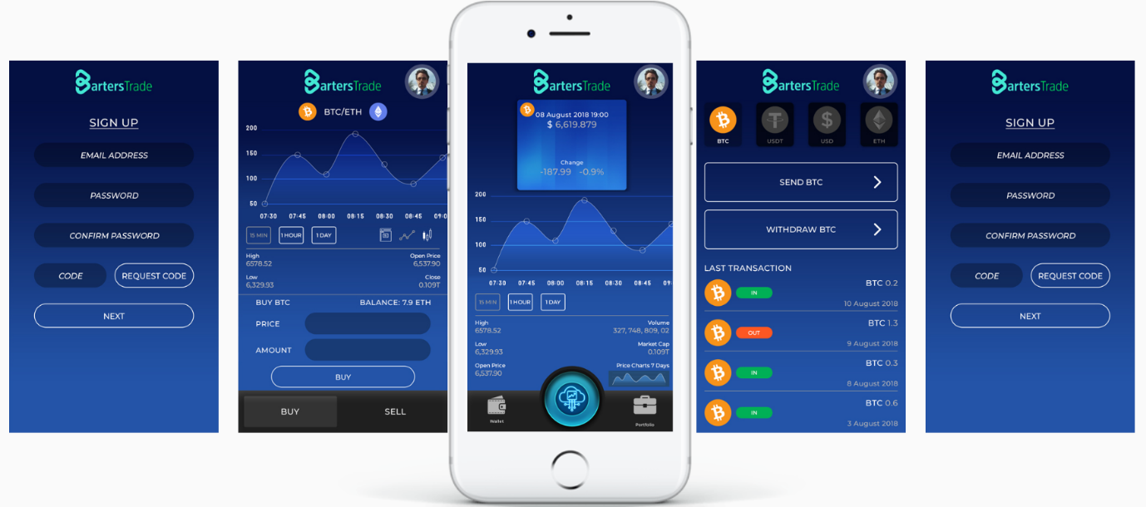
Similar to our Neuron Wallet we have created a simple application that is easy to use especially for our users that are unfamiliar with cryptocurrency or exchanges but still wish to participate.
- Unihash Blockchain
Block Structure
Our blocks only include necessary transactional information such as index, timestamp, data, hash, previous hash, difficulty and nonce.
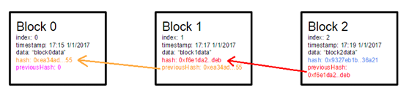
Block Hash
The block needs to be hashed to keep the integrity of the data. Secure Hash Algorithm - 256 is the cryptographic Hash and the signature we use on our Blockchain. Secure Algorithm – 256 is one of the most secure hashes available.
Storing the Blocks
MySQL is used to store the Unihash blockchain. The first block of the blockchain is a “genesis-block”, which is hard coded.
Validating the Integrity of Blocks
Validation of a block and determining its integrity is crucial to the blockchain. The following checks must be carried out to validate and ensure the integrity of new blocks:
a) correctness of new block index;
b) correctness of new block hash;
c) previous block hash must be recorded in new block's previous hash;
d) valid block timestamp where conditions below will be met:
i) A block is valid, if the timestamp is at most 1 minute in the future from the time we perceive;
ii) A block in the chain is valid, if the timestamp is at most 1 minute prior to the previous block;
e) block's body size must not exceed more than 1 megabyte.
Fork Issue, Choosing the Highest Cumulative Difficulty Chain
Each block must have its own unique identifier at any given time. In the event of conflict (e.g. two nodes both generate block number 72, we choose the chain that has the highest number of cumulative difficulties.
Communicating with Other Nodes
An essential function of a node is to share and sync the blockchain with other nodes. The following rules are used to keep the network synced.
- When a node generates a new block, it broadcasts it to the network.
- When a node connects to a new peer its query’s for the latest block.
- When a node encounters a block that has an index larger than the current known block, it will either add the block in its current chain or it will query for the full blockchain.
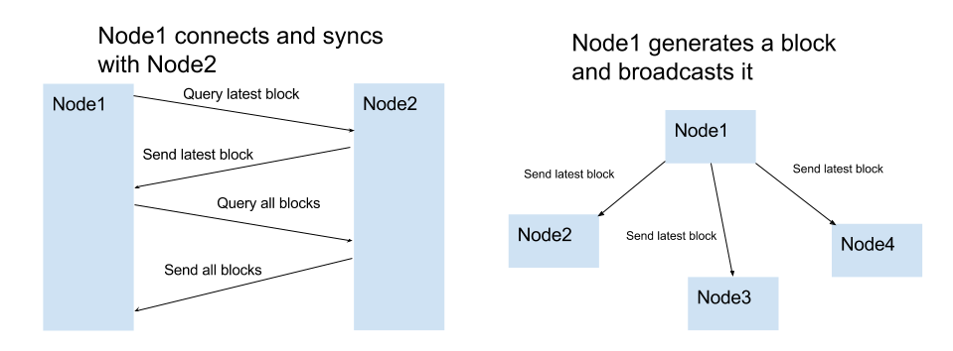
- Every new node will be hardcoded with preset seed node.
The seed node is reachable node used to prevent DNS failure and any other peer discovery mechanism failures.
- Staking
Users may Stake Unihash Coin or Unigram to receive Uni-E.
Staking Process:
- User downloads the IOS or android P.O.W.E.R application.

- User creates an account on P.O.W.E.R. The user must have a pool code to join.
- User deposits Unihash into P.O.W.E.R application;
- User opts to stake Unihash;
- Unihash is locked for a six-month period;
- Unihash user receives daily rewards in Uni-E;
- At the end of 6 months, user’s Unihash will be unlocked and available for spending or re-staking.
Unihash Pools
For network efficiency purposes Unihash only allows staking via staking pools. Thus, a Unihash user must have a pool code prior to signing up.
Generally, the more people in a Unihash pool the better the Uni-E reward is for everyone in that pool.
Uni-E Rewards
The rewards received in Uni-E will depend on how many people are staking in a pool, how much Unihash is being staked in that pool, how much Unihash is being staked in total and the volume of Uni-E being moved throughout the network.

Business Model
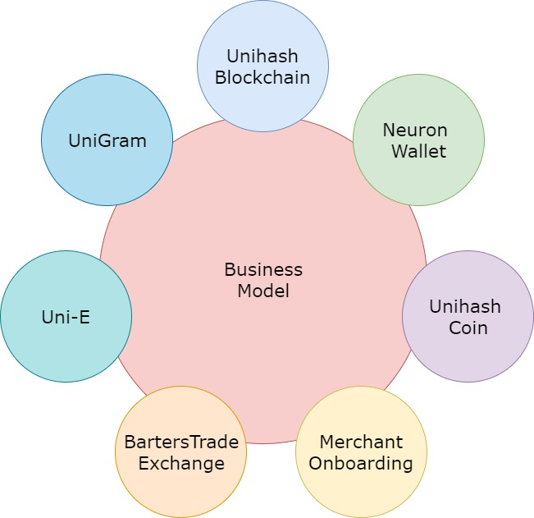
The Unihash Ecosystem consists of 7 different aspects which all work in unison to create the ecosystem.
Unihash Blockchain is the foundation for our business. Without the blockchain we are unable to implement any of the other aspects of our model.
Neuron Wallet allows our users to store their assets whether it be the Unihash coin or another form of digital currency.
Unihash Coin forms the basis of the digital currencies available. It will likely be traded as the main pair on Barters Trade as well as a transaction validator for Uni-E when staked.
Merchant Onboarding allows our users to spend their digital currency at various retailers.
Barters Trade Exchange Provides users with the capability to exchange their digital currency with other currencies including Unihash Coin, Bitcoin, Ethereum and Fiat Currency.
Unigram is a stable coin pegged to 1 USD.
Uni-E is our currency and Initial Exchange offering token. It will be used as a form of currency to purchase investments in which our ecosystem offers.
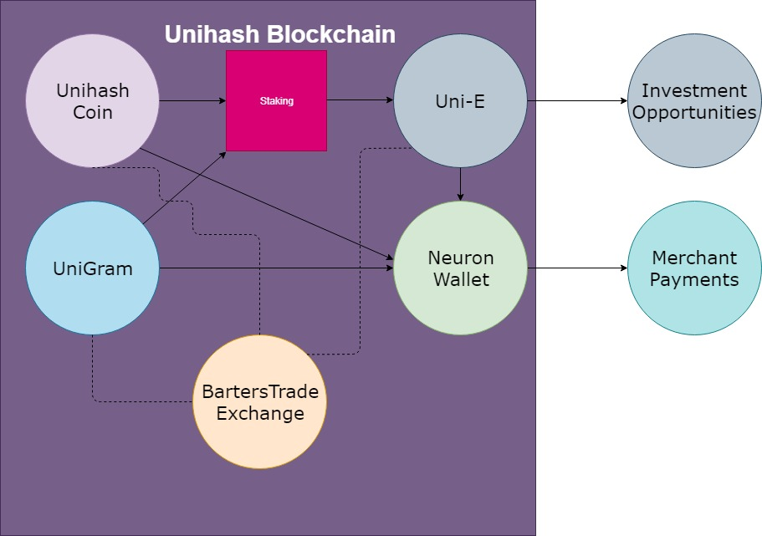

In the diagram above we have detailed aspects of our ecosystem and its connection with other aspects.
Unihash Coin, Unigram, Uni-E and the Neuron wallet are all built on top of the Unihash Blockchain. The Barters Trade Exchange has implemented the Unihash Blockchain into its workings.
When Unihash and UniG is staked, users receive Uni-E as a reward.
Unihash Coin, Uni-E and Unigram are all stored in a user’s Neuron wallet. These coins and tokens can also be deposited onto the Barters Trade exchange to exchange with each other and potentially other currencies.
We have onboarded multiple merchants that will accept our coins as payment for goods and services. Users can make payments to merchants via the Neuron wallet.

- Scalability
The Neuron merchant wallet is ready to be deployed at any retailer allowing retailers to accept Unihash ecosystem tokens/coins or Bitcoin as payment for their goods and/or services.
We have also developed API’s which can be deployed onto any online retailer’s webpage, allowing for fast payment and settlement via Unihash ecosystem tokens/coins or Bitcoin.
- Sustainability
Without receiving any revenue from our ecosystem, we have forecasted that we are able to sustain our ecosystem as well as future development of Unihash for a substantial period absent any revenue. However, moving past this period the sustainability of Unihash will be reliant upon its popularity as a payment mechanism whether that be for goods and services or what not.

- Marketing

Positioning

Unihash has positioned itself as an alternative currency payment service provider.

Competitors

Many people would consider Fiat Currency payment processing service providers such as Visa and Mastercard our main competitors, however we disagree.

We do not believe Fiat Currency will be abolished any time soon however there will be a large boom in alternative currency due to the technological advancements blockchain technology has provided.

Despite its overwhelming dominance, Fiat Currency does have flaws such as inflation and remittance fees, thus we believe that alternative currency and Fiat Currency can be used in conjunction with each other. Therefore, we do not believe Fiat Currency payment processing service providers are in direct competition with us.

Our most significant competitors would be other alternative digital currencies. Many of our competitors have superior marketing and brand imaging to us at this point in time. However, Unihash can boast that we have made our payment processing service available to a significant number of small retailers across Australia, Indonesia and Malaysia and China. We have made our product available to the moms and dads promoting adoption of blockchain in general.

Opportunities

Crypto currency and blockchain technology are in their infant stages, accordingly we have the opportunity to control a large market share of the international alternative currency payment service industry.

Unihash coin’s use cases are always expanding and we are always looking to enter into new markets. Markets that we will be focusing on in the present time and believe will present the most lucrative opportunities are traditional capital markets, e-sports and the gaming industry.

Threats

Similar to any business, there are threats that may jeopardise the overall success of a project.

Regulation is extremely difficult to control and can also be somewhat difficult to predict. At the time of the release of this Product Disclosure Statement, we have done everything possible to uphold any regulatory obligations and compliance procedures required of us. However, regulatory framework is prone to change and may change unfavourably. Due to regulatory unpredictability, especially in relation to blockchain technology and crypto currency, we would consider regulatory change our biggest threat. Despite being our biggest threat regulatory change may also present us with the biggest opportunity.

Target Market

Our target market is the average person.

The average person could be described as someone that does not understand how to use crypto currency or the nuances attached. It is a person that does not have the time to research or learn how to use cryptocurrency. They are people who wish to use the product without needing to know how it works in the background. Thus, simplicity can be considered our niche in the crypto currency market.

- Competitor Analysis
 | Unihash (UNH) | Bitcoin (BTC) | Bitcoin Cash (BCH)
Max Supply | 210,000,000 | 21,000,000 | 21,000,000
Circulating Supply | 210,000,000 | 17,660,662 | 17,743,663
Algorithm | SHA-256 | SHA-256 | SHA-256
Block Time | 2 Minutes | 11 Minutes 56 Seconds | 9 minutes 22 seconds
Consensus Algorithm | Proof of Work | Proof of Work | Proof of Work
Mining | Cloud mining only | Hardware Mining | Hardware Mining
Blockchain Size | 145 GB | 145 GB | 145 GB
Transactions per second (average) |  | 7 | 27
Decentralisation | Semi | Full | Full
Merchant Adoption | 500+ | Exceeding 100,000+ | Exceeding 100,000+
Purchase of goods and services | Yes | Yes | Yes
Purchase of Securities | Yes | No | No
Jurisdictional Compliance | Yes | Not Applicable | Not Applicable
Accountability | Unihash team will be accountable for any problems | No accountability | No accountability
Role-Back enabled | No | No | No
Burned Token Recovery | No | No | No
Pre-mined | Yes | No | No
Smart Contracts | Yes | No | No

Bitcoin is the most predominant crypto currency in the market thus we will be assessing Bitcoin as our initial competitor. Bitcoin Cash, being a fork of Bitcoin, will be assessed as our second competitor.
As displayed above Unihash’s specifications are similar to Bitcoin and Bitcoin Cash, however despite the similarities we aim to distance ourselves from the two and create something niche and novel. We hope to achieve this via our implementation of smart contracts.
Evidently both Bitcoin and Bitcoin Cash have an extensive adoption rate, but their adoption rate is not friendly to the average person due to its complexities of use. As previously mentioned, the “average person” is our target market and believe they would receive the most benefit from using Unihash.

- Roadmap

Complete | Business Model Developed  Funding Acquired  Unihash Blockchain Developed and Released  Mining Protocol Developed and Released  Neuron Wallet Developed and Released  Digital Currency Exchange Developed  Smart Contracts Beta Development  Merchant Onboarding  Expansion into Malaysia, Indonesia and Australia  P.O.W.E.R Application Developed and Released  Unigram Released  Uni-E Released
In Progress | Digital Currency Exchange Know Your Customer, Anti Money Laundering and Counter Terrorist Financing Provision Implementation  Further Smart Contract Development  Marketing  Western Market Entrance Strategy Formulation  Western Market Legal Structuring  Competitor Analysis  Partnership Development  Unihash Team Expansion
Backlog | South America Expansion  Africa Expansion  CoinmarketCap.com Application  Listing on Various Exchanges

- Intellectual property
All intellectual property of the Unihash ecosystem will be owned by UNIHASH. Dissemination or use of the Unihash system’s IP is strictly prohibited. Individuals may not use the Intellectual property of Unihash without express written consent from UNIHASH.
- Validity of Product Disclosure Statement
This Product Disclosure Statement will be valid for a period of 6 months beginning the publish date of this document.
- Blockchain
At its core, Blockchain technology provides a considerably more secure method of transferring data to other individuals. Many people associate Blockchain technology with decentralised digital currency such as Bitcoin and Ethereum. However, decentralised digital currency is a single use of Blockchain technology. Before participating in the UNIHASH ecosystem we suggest that you do your due diligence on Blockchain technology and the security benefits that it provides to consumers. Please distinguish Blockchain Technology from crypto currency and Digital Currency as they are only a single application of Blockchain Technology.
- Partnerships
We have partnered with multiple merchants in Malaysia, China, Indonesia and Australia. For a full list of merchant partners, please go to: www.shoppingpin.com.
- Team

- Definitions

Blockchain
Blockchain is a technology that refers to data being stored in blocks of memory. The blocks require the validation of multiple participants to confirm the data in the blocks are true before it can be published to the public.
Digital Currency Exchange
A Digital Currency Exchange is a market where users may exchange their digital currency for other digital currency or Fiat.
Digital Currency Offering
A digital currency offering is when an issuer of a digital currency allows the public to purchase their digital currency.
Fiat Currency
Generally referred to government issued currency such as United States Dollar or Australian Dollar.
Hash
A hash is a Uni directional function which cannot be decrypted back to its original text.
Mining
In certain blockchain protocols mining is used to verify transactions on the blockchain network. Mining is used to verify transaction on the Unihash platform.
Stable Coin
Stable Coins reference digital currency that are not subject to extreme volatility. Popular stable coins include assets backed, fiat backed or algorithmic.
Security Token
A security Token is a traditional security tokenised and placed on the blockchain. The most common being stocks and units in a unit trust.
Security Token Exchange
A security token exchange is a regulated security exchange that has undergone the technological advancement of allowing the exchange of security tokens.
Wallet
A wallet is referred to an application that allows an individual to store their digital currency. Different wallets store different digital currencies. Our Neuron Wallet stores Unihash Coins and Bitcoin.
QR Code
A QR code is a form of barcode the presents particular data when scanned.

